**About your team** – A brief team information such as

Team name: Go Go Gnomes , team with 6 members from ITM-2004. Our team lovers of delicious food, also ambitious and responsible individuals.Each member of the team knows their own role and importance of their work.

**Members and their roles –** name, student id, email, and role

Khalymbetova Kymbat ([204253@astanait.edu.kz](mailto:204253@astanait.edu.kz)) - Documentation, secondary coder and Team Leader  
Sadenova Dilnaz([204133@astanait.edu.kz](mailto:204133@astanait.edu.kz))- Main coder, Documentation assistant   
Toguzova Aliya([204110@astanait.edu.kz](mailto:204110@astanait.edu.kz)) - Design & Content, secondary coder  
Abduaitova Diana([204039@astanait.edu.kz](mailto:204039@astanait.edu.kz))- Main coder , Documentation assistant   
Yernazar Iliyas- Main coder, Documentation assistant   
Zeynullin Tamerlan([204142@astanait.edu.kz](mailto:204142@astanait.edu.kz))- Main coder, Design & Content assistant

**Communication strategy** – meeting and brainstorming minutes

-Tuesday was the first meeting , where we divided roles between members and also did brainstorming of the project, and we chose references for inspiration.   
-On Wednesday we started writing content/text and shooting photos, also tried to do basic prototype of website.   
-On Thursday we finished our prototype and map of the website, and collected information for the menu like the price, name of foods.   
-Friday we set on writing the documentation of the project and divide who will write which part, also filled some parts. After the lessons(in the evening) team members start the writing of codes and search for some bootstrap files.   
-Saturday team members continued writing codes and checking them for working and usefulness.  
-On Sunday Go Go Gnomes met at Starbucks and wrote the last parts of the documentation together, also final checking of the codes, design and changing some moments of the work.   
 **Motivation** – Why is the project needed?

Our motivation for doing this group project:  
Firstly, experience for a future career and understand the kitchen from the inside (teamwork + write a website from scratch). Secondly, given task our mid-term project-exam. And Thirdly, it is necessary to develop the efficiency of the canteen and the brand of the university, as well as to make life easier for the people who eat here.

* **High-level project scope** – Is it a redesign of a few pages, a complete website overhaul, or a brand-new website?

In reality in the task given creating brand-new website for our University Canteen, so for this reason we decided to create from zero new website to develop brand system of University and also to make easier life of students/employees of Astana IT University by having special website with prices, descriptions and menu of the food.

* **Target audience/market** – An overview of who this website is targeted at.

Target of the our project: students and employees of Astana IT University (from 16 to 50 ages)

# **Project goals and team interests**

Briefly describe the goals of the project and what will your team gain from doing this project. This will give an idea of what you are trying to achieve, which will enable the most appropriate solutions.

Project goals

* Contribute into marketing of university canteen.
* Increase the sales of canteen by creating a well-structured and convenient website that will attract the audience.
* Support the university's own brand and correspond to the name of IT university.

Team interests

* Understand the proper exploitation of HTML, CSS and learning the Bootstrap library.
* Gain experience in web development, which will give benefits in our further careers.
* Improve teamwork, communication skills by creating a friendly and loyal environment which will help project outcomes be successful.

# **Phases**

* Phase 1 – Brainstorming ideas regarding the website content within a team
* Phase 2 – Creating a prototype of a website using design constructors
* Phase 3 – Searching for information and data that will be included to the website (e.g. photos, prices, addresses etc.)
* Phase 4 – Writing codes on HTML based the content; styling the website using CSS and adding style tools using Bootstrap
* Phase 5 – Reviewing the outcome with all members of the group; adding corrections for further improvement

# **Content structure**

**Site map**

This is usually provided as a diagram which shows the ‘tree’ type, hierarchical structure of the website pages. It can also include which ‘page template’ (see below) to use for each page and content type. (gloomaps.com)

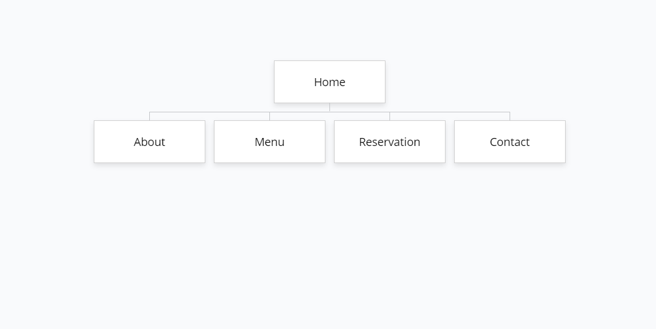

**Content types**

A website can contain many distinct types of content. At its most basic, there will usually be posts and pages. A page is timeless content, e.g. ‘About us’, whereas a post is chronological, e.g. a news or blog post.

There you can see our content to website:

**Main Page:** [**https://wireframe.cc/8DkA1P**](https://wireframe.cc/8DkA1P)

**Scondory Page: https:**[**//wireframe.cc/5Fnc7O**](https://wireframe.cc/5Fnc7O)

**Last Page:** [**https://wireframe.cc/pro/pp/989d32e75412846**](https://wireframe.cc/pro/pp/989d32e75412846)

Some other common examples of content types are:

* People, Audience - it’s like product description, shown here – may be set up to change the content according to any number of variables – in this case, the audience. Our site is viewed by people and audience.
* Events - what exactly our website is about

**Design**

It is important to provide design assets and related references

When it comes to the design requirements section in your documentation, it is advisable to include the following details to ensure that you and your team have everything they need to work effectively.

There are many ways to provide design assets, for example:

* Reference links- The above-mentioned links pushed and inspired our team. Thanks to that we realized our intention of a correct and logical position of the site.

1. <http://preview.themeforest.net/item/recibo-restaurant-food-html-template/full_screen_preview/23758795?_ga=2.151038010.264953528.1612433429-1565677922.1612255450>
2. <https://u-afanasicha.kz>

* Image files - Here you can see some of the pictures, which are on our website.

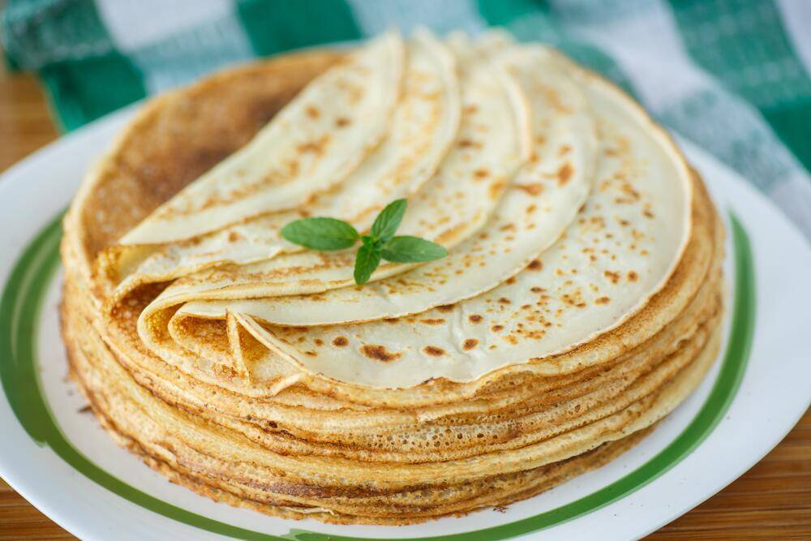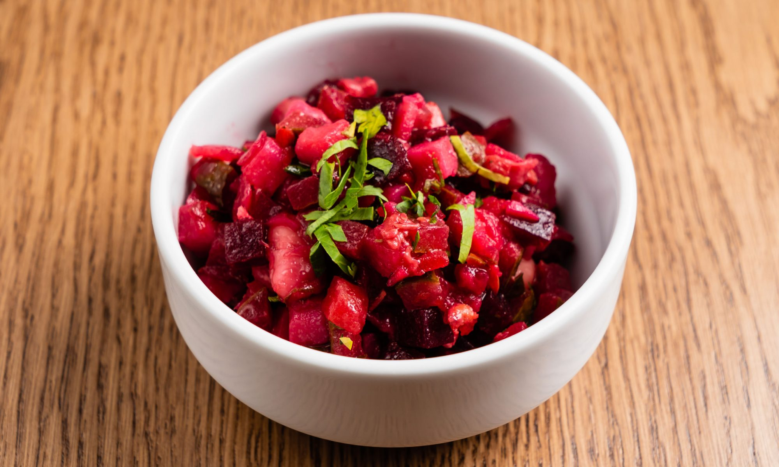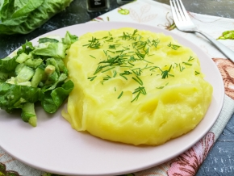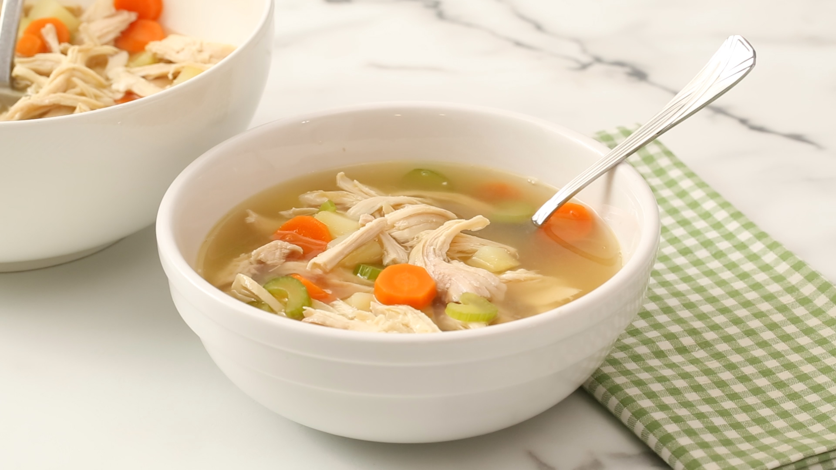

It is also important to provide a style guide and/or annotations for information such as:

* colours

#666, #fff, #222, #7f7f7f, #2b2b2b;

* typography rules:

fonts/genericons-regular-webfont.ttf

fonts/genericons-regular-webfont.eot?#iefix

**Functionality**

<http://eepurl.com/hpRhir>

1. Here fields for reservation form that we have:

* E-mail;
* First name;
* Amount of people;
* Phone number

All these fields are required. We created this sign form on <https://mailchimp.com> .

1. On contact form, that is in the footer part we have links to social media such as Instagram and What’s app.

**Hosting**

This section should outline the hosting requirements of the site. For example, if you used Github pages, indicate steps you took.

1. One of the main coders of our team created a Repository
2. Uploaded all necessary files there
3. Published the WEB page on git-hub
4. Get links for the repository and site itself

**Accessibility**

In the course of our work, we chose colors and fonts that do not weigh down the viewing of the site for customers and stakeholders. That is, not the most italic typefaces and bright colors.

**Deadlines**

It’s still important to have an idea of the timescales involved, especially if there is a fixed deadline – an event, for example. If you have provided project phases, it is mandatory to provide deadlines.

* Phase 1 – February 1, 17:00 - Distribution of responsibilities
* Phase 2 – February 3, 22:00 - Prototyping, content and sample design
* Phase 3 – February 5, 22:00 - Start to code, create a draft / skeleton web page
* Phase 4 - February 6, 20:00 - Choosing the final design and combining all the selected components for the site.
* Phase 5 - February 7, 22.00 - Final testing, documentation proofreading and web page publication on github

# **Summary**

Write down a brief summary of your website. Have you achieved the project goals/team interests? What difficulties have you faced during the project implementation? What have you learned?   
  
 To sum up, our team “Go Go Gnomes” did our best and tried to successfully complete the task with all requirements. During the team work each member of the group was active and participated from the beginning till the end of the project work. We think that we achieved all our project goals and cover our interests, for example in the beginning of the work we wanted .But of course without challenges it didn't work out , as well as we were work 6 people together and each member had own vision/view , so to choose design was difficult and also dividing roles between members to complete each point correctly took the time. Also, before the brainstorming we did not choose our team leader so for that we were disappointed with all and faces challenges what we mentioned in previous sentences, and in the Tuesday we found our team leader and work gone fast and efficiency for our group. By the way , these problems were during the organization moments and in the process we faced with some problems with writing correct code and choosing right bootstrap prototypes. And filling the website with high-quality content has own trouble due to that we collect/did some photos in canteen during the mid-term exams and learning menu of the canteen, after rewrite in electronic version took many time. Finally, we have learned to work and organize better team work, also it was interesting experience related with our professions such as creating web-site and of course manage team-work with greatest time-management, which will save our nerve systems from stress during the a weekend littered with deadlines and midterm exams..